open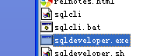，goto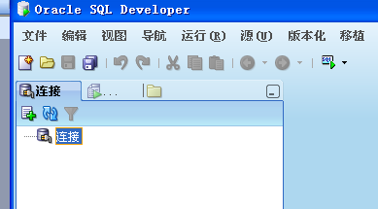，
right click on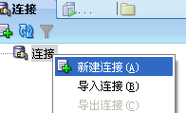，
New connection
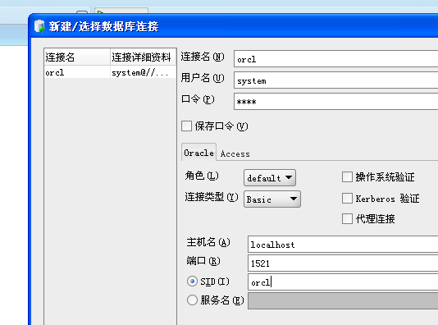
Put in like this above(password is oracle)
Copy from database 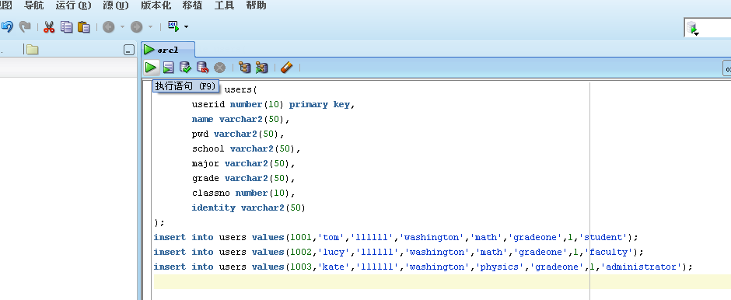F9 and F11 to run, then select * from users;if shows like this: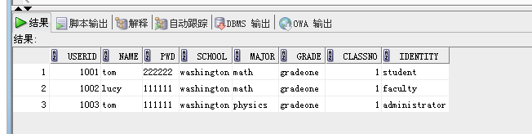our database works perfect.

jdbc:oracle:thin://127.0.0.1:1521/orcl

